영상처리 HW 4

16010980 이우석

# 결과

< 원본 이미지 - czp.pgm >

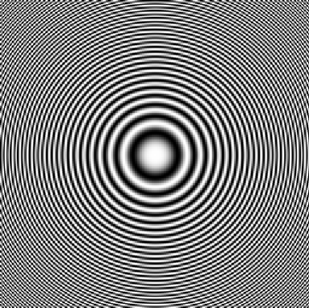

< 2.0 scale Bilinear – czp_2.0scaleBili.pgm >

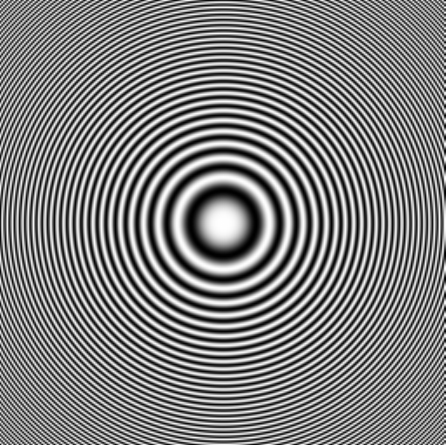

< 2.0 scale Cubic convolution – czp_2.0scaleCubic.pgm >

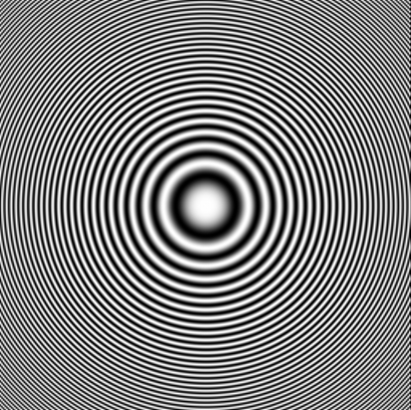

< 원본 이미지 - lena.pgm >

< 2.0 scale Bilinear – lena_2.0scaleBili.pgm >

< 2.0 scale Cubic convolution – lena_2.0scaleCubic.pgm >

# 코드

< bilinear() >

void bilinear(image_ptr buffer, char* fileout, int rows, int cols,

float x_scale, float y_scale, int type)

{

unsigned long x, y; /* loop indices for columns and rows */

unsigned long index; /* index into line buffer */

unsigned long source_index; /* address of source pixel in image buffer */

unsigned char* line_buff; /* output line buffer */

int new_rows, new_cols; /* values of rows and columns for new image */

unsigned line; /* number of pixels in one scan line */

FILE* fp; /* output file pointer */

unsigned long X_Source, Y_Source; /* x and y address of source pixel */

pixel_ptr color_buff; /* pointer to a color image in memory */

int NW, NE, SW, SE, result;

float EWweight, NSweight, EWtop, EWbottom;

/* open new output file */

if ((fp = fopen(fileout, "wb")) == NULL)

{

printf("Unable to open %s for output\n", fileout);

exit(1);

}

new_cols = cols * x_scale;

new_rows = rows * y_scale;

/* print out the portable bitmap header */

fprintf(fp, "P%d\n%d %d\n255\n", type, new_cols, new_rows);

if (type == 5) /* PGM file */

line = new_cols;

else /* PPM file */

{

line = new_cols * 3;

color_buff = (pixel_ptr)buffer;

}

line_buff = (unsigned char*)malloc(line);

for (y = 0; y < new_rows; y++)

{

index = 0;

for (x = 0; x < new_cols; x++)

{

X_Source = (unsigned long)(x / x_scale);

Y_Source = (unsigned long)(y / y_scale);

if (type == 5) /* PGM */

{

/* bilinear interpolation */

// duplicate the border edges

NW = buffer[Y_Source * cols + X_Source];

if (X_Source + 1 >= cols && Y_Source + 1 >= rows)

{

NE = NW;

SW = NW;

SE = NW;

}

else if (X_Source + 1 >= cols)

{

NE = NW;

SW = buffer[(Y_Source + 1) * cols + X_Source];

SE = SW;

}

else if (Y_Source + 1 >= rows)

{

NE = buffer[Y_Source * cols + X_Source + 1];

SW = NW;

SE = NE;

}

else

{

NE = buffer[Y_Source * cols + X_Source + 1];

SW = buffer[(Y_Source + 1) * cols + X_Source];

SE = buffer[(Y_Source + 1) * cols + X_Source + 1];

}

EWweight = (x / x_scale) - (float)X_Source;

NSweight = (y / y_scale) - (float)Y_Source;

EWtop = NW + EWweight * (NE - NW);

EWbottom = SW + EWweight * (SE - SW);

result = EWtop + NSweight * (EWbottom - EWtop);

line_buff[index++] = result;

}

else /* PPM */

{

line_buff[index++] = color_buff[source_index].r;

line_buff[index++] = color_buff[source_index].g;

line_buff[index++] = color_buff[source_index].b;

}

}

fwrite(line_buff, 1, line, fp);

}

fclose(fp);

}

< cubic_convolution() >

void cubic_convolution(image_ptr buffer, char* fileout, int rows, int cols,

float x_scale, float y_scale, int type)

{

unsigned long x, y; /* loop indices for columns and rows */

unsigned long index; /* index into line buffer */

unsigned long source_index; /* address of source pixel in image buffer */

unsigned char* line_buff; /* output line buffer */

int new_rows, new_cols; /* values of rows and columns for new image */

unsigned line; /* number of pixels in one scan line */

FILE* fp; /* output file pointer */

unsigned long X_Source, Y_Source; /* x and y address of source pixel */

pixel_ptr color_buff; /* pointer to a color image in memory */

int cubic_arr[4][4], i, j;

int arr_x, arr_y;

float cubic_EWweight[4], cubic_NSweight[4], cubic_intermResult[4], cubic_result, dif_tmp, a = -0.5f; // a (계수) 의 값 : -0.5f

/* open new output file */

if ((fp = fopen(fileout, "wb")) == NULL)

{

printf("Unable to open %s for output\n", fileout);

exit(1);

}

new_cols = cols * x_scale;

new_rows = rows * y_scale;

/* print out the portable bitmap header */

fprintf(fp, "P%d\n%d %d\n255\n", type, new_cols, new_rows);

if (type == 5) /* PGM file */

line = new_cols;

else /* PPM file */

{

line = new_cols * 3;

color_buff = (pixel_ptr)buffer;

}

line_buff = (unsigned char*)malloc(line);

for (y = 0; y < new_rows; y++)

{

index = 0;

for (x = 0; x < new_cols; x++)

{

X_Source = (unsigned long)(x / x_scale);

Y_Source = (unsigned long)(y / y_scale);

if (type == 5) /* PGM */

{

/* cubic convolution interpolation */

// 배열에 픽셀 값을 배치.

arr_y = Y_Source - 1;

for (i = 0; i < 4; i++)

{

arr_x = X_Source - 1;

for (j = 0; j < 4; j++)

{

// zero padding

if (arr_y < 0 || arr_x < 0 || arr_y >= rows || arr_x >= cols)

cubic_arr[i][j] = 0;

else

cubic_arr[i][j] = buffer[arr_y * cols + arr_x];

arr_x++;

}

arr_y++;

}

// 가로 가중치 계산.

arr_x = X_Source - 1;

for (i = 0; i < 4; i++)

{

dif_tmp = fabsf((x / x_scale) - arr_x);

if (0 <= dif_tmp && dif_tmp < 1)

cubic_EWweight[i] = (a + 2) * pow(dif_tmp, 3) - (a + 3) * pow(dif_tmp, 2) + 1;

else if (1 <= dif_tmp && dif_tmp < 2)

cubic_EWweight[i] = a * pow(dif_tmp, 3) - 5 * a * pow(dif_tmp, 2) + 8 * a * dif_tmp - 4 * a;

else

cubic_EWweight[i] = 0;

arr_x++;

}

// 세로 가중치 계산.

arr_y = Y_Source - 1;

for (i = 0; i < 4; i++)

{

dif_tmp = fabsf((y / y_scale - arr_y));

if (0 <= dif_tmp && dif_tmp < 1)

cubic_NSweight[i] = (a + 2) * pow(dif_tmp, 3) - (a + 3) * pow(dif_tmp, 2) + 1;

else if (1 <= dif_tmp && dif_tmp < 2)

cubic_NSweight[i] = a * pow(dif_tmp, 3) - 5 * a * pow(dif_tmp, 2) + 8 * a * dif_tmp - 4 * a;

else

cubic_NSweight[i] = 0;

arr_y++;

}

// 가로 가중치를 이용하여 중간 결과값 계산.

for (i = 0; i < 4; i++)

{

cubic_intermResult[i] = 0;

for (j = 0; j < 4; j++)

{

cubic_intermResult[i] += cubic_EWweight[j] * cubic_arr[i][j];

}

}

// 세로 가중치를 이용하여 최종 결과값 계산.

cubic_result = 0;

for (i = 0; i < 4; i++)

{

cubic_result += cubic_NSweight[i] * cubic_intermResult[i];

}

// float 형식의 특성 상 계산 상의 약간의 오차가 발생하는데 이 때문에 오버플로우, 언더플로우가 발생.

// 이를 CLIP 함수를 이용하여 조정.

CLIP(cubic_result, 0, 255);

line_buff[index++] = cubic_result;

}

else /* PPM */

{

line_buff[index++] = color_buff[source_index].r;

line_buff[index++] = color_buff[source_index].g;

line_buff[index++] = color_buff[source_index].b;

}

}

fwrite(line_buff, 1, line, fp);

}

fclose(fp);

}